Chapter 15, Problem 18.

Obtain the Laplace transforms of the functions in Fig. 15.30.

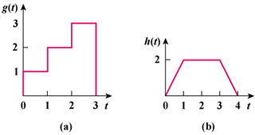

Figure 15.30
For Prob. 15.18.

